Jesse Chen, Ojan Thonrycroft

Assignment 2

There were a number of design options to choose from in the lecture slides, but for this project, we decided to mostly stick with the final design that was agreed upon in class. More specifically, we chose a design (pictured below) that most closely resembled what we were already most familiar with from CS 2110 and CS 2200, with a few minor modifications to fit the design given in class. As such, a majority of the code given to us was left unchanged. The only code that had to be added involved filling in the logic within certain components of the design that were already outlined for us. This includes decoding the instructions, implementing the ALU, implementing the FPGA board’s memory-mapped I/O, defining the processor states and their transitions (also pictured below), and implementing the sign extender.

Decoding instructions was simple enough, since we just used the prescribed ISA to decode the 32-bit instructions into each of the six possible components: op1 [31:26], op2 [25:18], imm [23:8], rd [11:8], rs [7:4], and rt [3:0]. The ALU was mostly just a matter of defining each of its 14 different operations and mapping its output depending on what function it was currently set to use. Implementing our FPGA board’s memory-mapped I/O involved overriding the LW and SW instructions when the MAR contained certain addresses that mapped to the board’s I/O. In these cases, instead of reading and writing to data memory, it read and wrote to the board’s I/O. In terms of processor states, our processor had a total of 36 different states, including an error state. Each instruction has a series of states that it goes through before restarting to fetch the next instruction, and each state defines which signals are to be turned on at any point in an instruction’s execution. Finally, a sign extender module was already given to us, but we simply had to define its parameters and add it to our design.

The biggest issue that I ran into was that our ALU didn’t seem to do anything but add. After a very long debugging process, I found that ALUfunc was getting reset to 0 at every clock cycle, which is mapped to addition. This was a problem because we had initially set ALUfunc during FETCH2, before the ALU was ready to drive its output in ALUI3/ALUR3. To fix this, I added an ALUfunc_buffer as a new register to save ALUfunc until the ALU was ready. Now, where we originally set ALUfunc in FETCH2, I set ALUfunc_buffer instead, and in ALUI3/ALUR3, I set ALUfunc to ALUfunc_buffer. This fixed the ALU problem we were having; it also made the compiler warn us not to use such a register as a latch, but I’m not sure why.

My individual contribution to this project consisted of designing our processor’s state machine and working out how the memory-mapped I/O worked. My original code to handle memory-mapped I/O didn’t work to begin with, but my partner and I both debugged it together, along with the rest of the code as well. I believe my contribution was about 40-50% of the project.

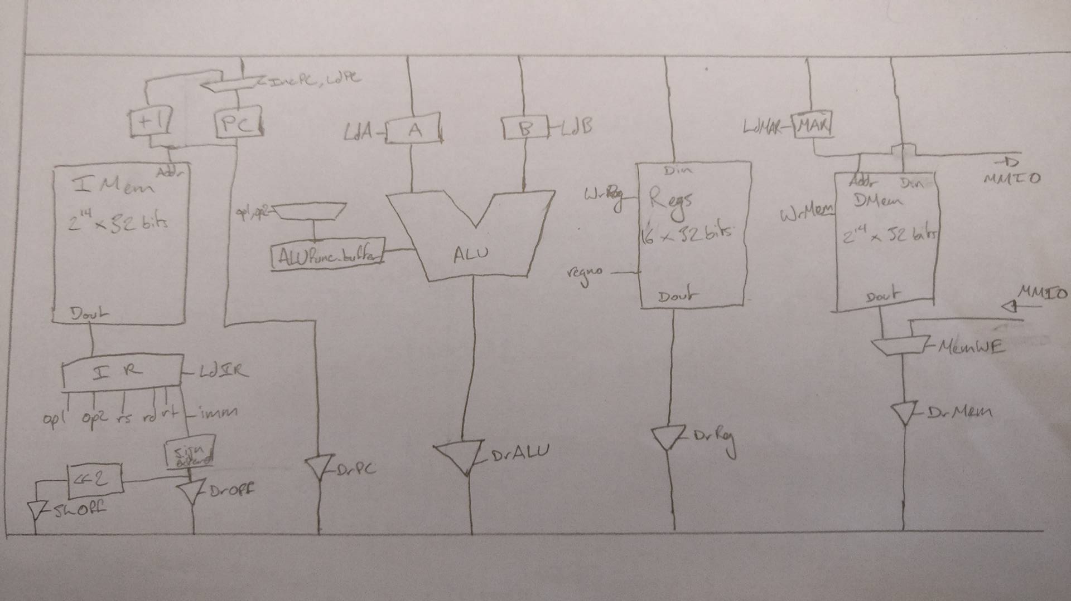

|  |  |  |  |  |  |  |  |  |  |  |  |  |  |  |  |  |  |  |
| --- | --- | --- | --- | --- | --- | --- | --- | --- | --- | --- | --- | --- | --- | --- | --- | --- | --- | --- |
| State # | Macro State | LdPC | DrPC | IncPC | LdMAR | WrMem | DrMem | LdIR | DrOff | ShOff | LdA | LdB | ALUfunc | DrALU | RegSel | DrReg | WrReg | next_state |
| 0 | FETCH1 | 0 | 0 | 1 | 0 | 0 | 0 | 1 | 0 | 0 | 0 | 0 | 0000 | 0 | 00 | 0 | 0 | FETCH2 |
| 1 | FETCH2 | 0 | 0 | 0 | 0 | 0 | 0 | 0 | 0 | 0 | 0 | 0 | 0000 | 0 | 00 | 0 | 0 | Check op1 and op2 |
| 2 | ALUR1 | 0 | 0 | 0 | 0 | 0 | 0 | 0 | 0 | 0 | 1 | 0 | 0000 | 0 | 00 | 1 | 0 | ALUR2 |
| 3 | ALUR2 | 0 | 0 | 0 | 0 | 0 | 0 | 0 | 0 | 0 | 0 | 1 | 0000 | 0 | 01 | 1 | 0 | ALUR3 |
| 4 | ALUR3 | 0 | 0 | 0 | 0 | 0 | 0 | 0 | 0 | 0 | 0 | 0 | 0011 | 1 | 10 | 0 | 1 | FETCH1 |
| 5 | ALUI1 | 0 | 0 | 0 | 0 | 0 | 0 | 0 | 0 | 0 | 1 | 0 | 0000 | 0 | 00 | 1 | 0 | ALUI2 |
| 6 | ALUI2 | 0 | 0 | 0 | 0 | 0 | 0 | 0 | 1 | 0 | 0 | 1 | 0000 | 0 | 00 | 0 | 0 | ALUI3 |
| 7 | ALUI3 | 0 | 0 | 0 | 0 | 0 | 0 | 0 | 0 | 0 | 0 | 0 | 0000 | 1 | 01 | 0 | 1 | FETCH1 |
| 8 | BEQ1 | 0 | 0 | 0 | 0 | 0 | 0 | 0 | 0 | 0 | 1 | 0 | 0000 | 0 | 00 | 1 | 0 | BEQ2 |
| 9 | BEQ2 | 0 | 0 | 0 | 0 | 0 | 0 | 0 | 0 | 0 | 0 | 1 | 0000 | 0 | 01 | 1 | 0 | BEQ3 |
| 10 | BEQ3 | 0 | 0 | 0 | 0 | 0 | 0 | 0 | 0 | 0 | 0 | 0 | 1010 | 1 | 00 | 0 | 0 | (bus==1)?BR1:FETCH1 |
| 11 | BNE1 | 0 | 0 | 0 | 0 | 0 | 0 | 0 | 0 | 0 | 1 | 0 | 0000 | 0 | 00 | 1 | 0 | BNE2 |
| 12 | BNE2 | 0 | 0 | 0 | 0 | 0 | 0 | 0 | 0 | 0 | 0 | 1 | 0000 | 0 | 01 | 1 | 0 | BNE3 |
| 13 | BNE3 | 0 | 0 | 0 | 0 | 0 | 0 | 0 | 0 | 0 | 0 | 0 | 1101 | 1 | 00 | 0 | 0 | (bus==1)?BR1:FETCH1 |
| 14 | BLT1 | 0 | 0 | 0 | 0 | 0 | 0 | 0 | 0 | 0 | 1 | 0 | 0000 | 0 | 00 | 1 | 0 | BLT2 |
| 15 | BLT2 | 0 | 0 | 0 | 0 | 0 | 0 | 0 | 0 | 0 | 0 | 1 | 0000 | 0 | 01 | 1 | 0 | BLT3 |
| 16 | BLT3 | 0 | 0 | 0 | 0 | 0 | 0 | 0 | 0 | 0 | 0 | 0 | 1011 | 1 | 00 | 0 | 0 | (bus==1)?BR1:FETCH1 |
| 17 | BLE1 | 0 | 0 | 0 | 0 | 0 | 0 | 0 | 0 | 0 | 1 | 0 | 0000 | 0 | 00 | 1 | 0 | BLE2 |
| 18 | BLE2 | 0 | 0 | 0 | 0 | 0 | 0 | 0 | 0 | 0 | 0 | 1 | 0000 | 0 | 01 | 1 | 0 | BLE3 |
| 19 | BLE3 | 0 | 0 | 0 | 0 | 0 | 0 | 0 | 0 | 0 | 0 | 0 | 1100 | 1 | 00 | 0 | 0 | (bus==1)?BR1:FETCH1 |
| 20 | BR1 | 0 | 1 | 1 | 0 | 0 | 0 | 0 | 0 | 0 | 1 | 0 | 0000 | 0 | 00 | 0 | 0 | BR1 |
| 21 | BR2 | 0 | 0 | 0 | 0 | 0 | 0 | 0 | 0 | 1 | 0 | 1 | 0000 | 0 | 00 | 0 | 0 | BR2 |
| 22 | BR3 | 1 | 0 | 0 | 0 | 0 | 0 | 0 | 0 | 0 | 0 | 0 | 0000 | 1 | 00 | 0 | 0 | FETCH1 |
| 23 | JAL1 | 0 | 1 | 0 | 0 | 0 | 0 | 0 | 0 | 0 | 0 | 0 | 0000 | 0 | 01 | 0 | 1 | JAL2 |
| 24 | JAL2 | 0 | 0 | 0 | 0 | 0 | 0 | 0 | 0 | 0 | 1 | 0 | 0000 | 0 | 00 | 1 | 0 | JAL3 |
| 25 | JAL3 | 0 | 0 | 0 | 0 | 0 | 0 | 0 | 0 | 1 | 0 | 1 | 0000 | 0 | 00 | 0 | 0 | JAL4 |
| 26 | JAL4 | 1 | 0 | 0 | 0 | 0 | 0 | 0 | 0 | 0 | 0 | 0 | 0000 | 1 | 00 | 0 | 0 | FETCH1 |
| 27 | SW1 | 0 | 0 | 0 | 0 | 0 | 0 | 0 | 0 | 0 | 1 | 0 | 0000 | 0 | 00 | 1 | 0 | SW2 |
| 28 | SW2 | 0 | 0 | 0 | 0 | 0 | 0 | 0 | 1 | 0 | 0 | 1 | 0000 | 0 | 00 | 0 | 0 | SW3 |
| 29 | SW3 | 0 | 0 | 0 | 1 | 0 | 0 | 0 | 0 | 0 | 0 | 0 | 0000 | 1 | 00 | 0 | 0 | SW4 |
| 30 | SW4 | 0 | 0 | 0 | 0 | 1 | 0 | 0 | 0 | 0 | 0 | 0 | 0000 | 0 | 01 | 1 | 0 | FETCH1 |
| 31 | LW1 | 0 | 0 | 0 | 0 | 0 | 0 | 0 | 0 | 0 | 1 | 0 | 0000 | 0 | 00 | 1 | 0 | LW2 |
| 32 | LW2 | 0 | 0 | 0 | 0 | 0 | 0 | 0 | 1 | 0 | 0 | 1 | 0000 | 0 | 00 | 0 | 0 | LW3 |
| 33 | LW3 | 0 | 0 | 0 | 1 | 0 | 0 | 0 | 0 | 0 | 0 | 0 | 0000 | 1 | 00 | 0 | 0 | LW4 |
| 34 | LW4 | 0 | 0 | 0 | 0 | 0 | 1 | 0 | 0 | 0 | 0 | 0 | 0000 | 0 | 01 | 0 | 1 | FETCH1 |

|  |  |  |  |  |  |  |
| --- | --- | --- | --- | --- | --- | --- |
|  | ALUfunc |  |  |  | RegSel |  |
| 0 | 0000 | ADD |  | 0 | 00 | Rs |
| 1 | 0001 | AND |  | 1 | 01 | Rt |
| 2 | 0010 | OR |  | 2 | 10 | Rd |
| 3 | 0011 | XOR |  | 3 | 11 | N/A |
| 4 | 0100 | SUB |  |  |  |  |
| 5 | 0101 | NAND |  |  |  |  |
| 6 | 0110 | NOR |  |  |  |  |
| 7 | 0111 | NXOR |  |  |  |  |
| 8 | 1000 | RSHF |  |  |  |  |
| 9 | 1001 | LSHF |  |  |  |  |
| 10 | 1010 | EQ |  |  |  |  |
| 11 | 1011 | LT |  |  |  |  |
| 12 | 1100 | LE |  |  |  |  |
| 13 | 1101 | NE |  |  |  |  |